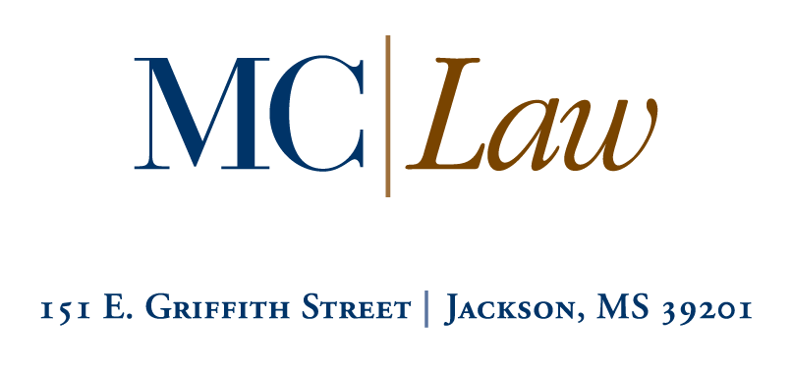

PRO BONO RECOGNITION PROGRAM

2016-17 Work Verification Form (Time Sheet)
Hours Worked after April 15, 2016 (class of 2017 and 2018 only)
Submit to Sherry Johnson, Assistant Dean of Student Services and Career Services

Please have your supervisor fill out the following form regarding the nature of your volunteer work. Make a copy of this form if you need additional space.
Name: |  |  |  | Date:
Address:
City: | State: |  | Zip Code: |  | Phone #:
Email: |  | Have you turned in Pro Bono Hours for a previous academic year? If Yes, what year: __________ |  |  | Graduation Year:

Volunteer Activities (60 Total Hours Required)
Calculate your time in .25ths (quarters). Hours may be combined to reach a total of 60. Please indicate specific volunteer events, duties, or responsibilities, corresponding dates and recorded time.
Organization:
Organization Address:
Supervisor’s Name: Extension Number:
Organization’s  Phone Number: |  | Email  Address: | Total Hours  Worked:
Date/s Worked | Description of Activity |  |  | Recorded Time
Supervisor’s Signature: Date:
Organization:
Organization Address:
Supervisor’s Name: Extension Number:
Organization’s  Phone Number: |  | Email  Address: | Total Hours  Worked:
Date/s Worked | Description of Activity |  |  | Recorded Time
Supervisor’s Signature: Date:

Organization:
Organization Address:
Supervisor’s Name: Extension Number:
Organization’s  Phone Number: |  | Email  Address: | Total Hours  Worked:
Date/s Worked | Description of Activity |  |  | Recorded Time
Supervisor’s Signature: Date:

I certify that on the above dates, I worked a total of ______ hours of Pro Bono work (not for credit or compensation).

MC Law Student Signature Date
Please return completed forms to:

Sherry Johnson
Assistant Dean of Student Services and Career Services
Mississippi College School of Law
151 East Griffith Street
Jackson, MS 39201, 601-925-7109

